Washington State All-Payer Claims Database and Lead Organization biennial report

  - Cost, performance, and effectiveness of the database and performance of the Lead Organization
Engrossed Substitute Senate Bill 5741, Section 8(1); Chapter 319; Laws of 2019
March 31, 2022

Washington State All-Payer Claims Database and Lead Organization biennial report

Acknowledgements
Washington State Health Care Authority (HCA) acknowledges the support of, and contributions made to this report by, WA-APCD program partners Forum One and Onpoint Health Data.

Clinical Quality and Care Transformation  P.O. Box 45502  Olympia, WA 98504  Phone: (360) 725-1612  Fax: (360) 586-9551  hca.wa.gov | Forum One  2101 4th Ave #2000  Seattle, WA 98121  Phone: (206) 623-1556  https://www.forumone.com | Onpoint Health Data  55 Washington Ave  Portland, ME 04101  Phone: (207) 623-2555  https://www.onpointhealthdata.org

Table of contents
Executive summary 5
Costs to administer the WA-APCD 6
Background 6
WA-APCD budget and expenditures 6
LO services: maintaining program operations 6
Data vendor services: maintaining the WA-APCD 6
Web vendor services: maintaining Washington HealthCareCompare 7
Table 1 WA-APCD budget and expenditure detail 9
Seeking funding 9
The Centers for Medicare & Medicaid Services matching funds 9
WA-APCD performance 10
Submitter registration 10
Data submission and monitoring 10
Table 3 WA-APCD covered lives and claims during calendar years 2019 and 2020, by market segment 10
Data security and quality 11
WA-APCD committees’ contributions to the database efficiency efforts† 12
State Agency Coordinating Committee 12
HCA WA-APCD Oversight Committee 12
WA-APCD Data Release Advisory Committee 13
WA-APCD Data Policy Advisory Committee 13
Select Committee 13
WA-APCD effectiveness 14
Increasing transparency using WA-APCD data 14
Washington HealthCareCompare (WAHCC) 14
WAHCC website utilization report 14
Data release program 14
Table 4 Data use agreement product types by organization 15
Select WA-APCD use cases 16
WA-APCD surprise billing data set 16
Cost of diagnosed diabetes in Washington State 16
Improving Parkinson’s disease care in underserved communities 16
Other publicly published reports derived from WA-APCD data 16
WA-APCD data fee waivers and reductions 17
Performance of the Lead Organization (LO) 18
LO Activity Summary 18
How the database can be improved 19
Conclusion 20
Summary and next report contents 20
Appendix A: 21
WA-APCD committee rosters 21

Executive summary
Engrossed Substitute Senate Bill (ESSB) 5741 (2019) made changes to support future operations of the Washington All-Payer Claims Database (WA-APCD). These changes included:
- Transferring authority and oversight for the database from the Washington (WA) State Office of Financial Management (OFM) to the Washington State Health Care Authority (HCA).
- Other changes to improve and ensure successful and sustainable database operations for access to and use of the data to improve health care, provide consumers useful and consistent quality and cost measures, and assess total cost of care in WA.
Section 8(1) of the bill states:
The authority shall report every two years to the appropriate committees of the legislature regarding the cost, performance, and effectiveness of the database and the performance of the lead organization under its contract with the authority. Using independent economic expertise, subject to appropriation, the report must evaluate whether the database has advanced the goals set forth in RCW 43.371.020(1), as well as the performance of the lead organization. The report must also make recommendations regarding but not limited to how the database can be improved, whether the contract for the lead organization should be modified, renewed, or terminated, and the impact the database has had on competition between and among providers, purchasers, and payers.
This report details the administration of the WA-APCD between July 1, 2019, and June 30, 2021. Those two fiscal years (FYs) were marked by a WA-APCD program transition from OFM to HCA and ongoing oversight of data submission, data release and consumer-facing website operations as well as organizational and analytic capacity building, all made possible through funding allocated by the Washington State Legislature during the 2019 session. The 2020 legislative session also saw the passage of HB 2457 establishing the state’s Health Care Cost Transparency Board. The Board, staffed and supported by HCA, now utilizes the WA-APCD as a critical resource for meeting legislative requirements to report on health care expenditures and cost growth in Washington.
Key takeaways from this report include the following:
- The total biennial WA-APCD program cost was $2,186,129
- CMS matching funds were secured to include a one-time retroactive payment for Medicaid-only operating costs of the database
- Over 5 million lives with medical coverage (70% of the total WA population) were represented in the database during calendar years 2019 and 2020
- The program used methods and experts in health data assessment, while carefully following standard processes to check that the data is valid and reliable
- 6 WA-APCD committees contributed to database efficiency and effectiveness
- WA-APCD website use increased by 55% over the two year reporting period
- The LO fulfilled data requests for 13 different stakeholder organizations
- 3 example use cases illustrate how WA-APCD data is being leveraged by data users to promote price transparency and better health care

Costs to administer the WA-APCD

Background
In the 2019-2021 biennial budget, the Legislature appropriated approximately $1.1 million to OFM to continue operating and maintaining the WA-APCD from July 1, 2019, through December 31, 2019. The Legislature also appropriated $3.54 million to HCA to maintain and continue WA-APCD operations, contract with a new Lead Organization (LO), and provide data access to state agencies from January 1, 2020, through June 30, 2021.
HCA conducted a procurement for a LO in the fall of 2019 and in October announced the Washington Health Alliance (WHA) as the apparent successful bidder. Contract negotiations did not finish by the end of 2019, and HCA took over the duties of the LO on Jan 1, 2020. Negotiations continue and HCA continues to act in an interim capacity as the State’s LO for the WA-APCD. HCA intends to seek funding for resources to procure independent economic expertise during the 2023-2025 biennium, thus enabling full reporting requirements outlined in statute to be addressed in a future reporting period.

WA-APCD budget and expenditures

LO services: maintaining program operations
During this FY2020/FY2021 reporting period, HCA, acting as the LO, maintained management, funding, and operations of the database as provided in Chapter 43.371 Revised Code of Washington (RCW) and Chapter 182-70 Washington Administrative Code (WAC).

Data vendor services: maintaining the WA-APCD
The WA-APCD includes data from calendar year 2014 onward with eligibility and claims data for over 5 million covered lives, representing approximately 70% of the total WA population. During the FY2020/FY2021 reporting period, the WA-APCD collected eligibility files and medical, dental and pharmacy claims data from the following entities: Medicaid (FFS and Managed Care), Medicare (FFS and Managed Care), Public Employees Benefits Board, School Employees Benefits Board, Washington State Department of Labor and Industries, and Washington’s commercial payers. Self-insured plans are invited to submit data on a voluntary basis to the database and these data are reflected in Table 3 on page 10 of this report.
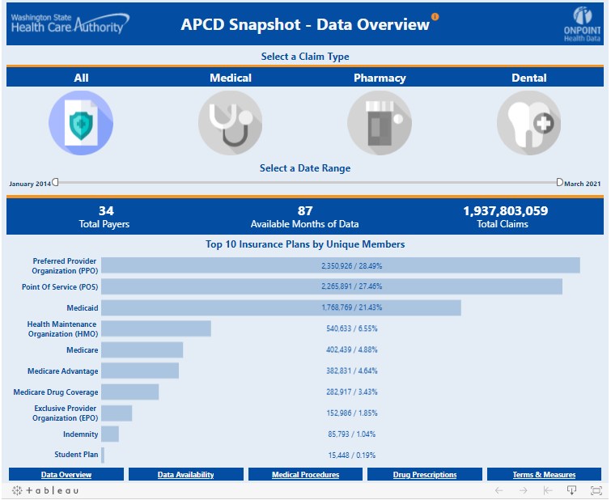
Figure 3 WA-APCD Snapshot – Data Overview
Refer to the “Terms and Measures” tab on https://www.wahealthcarecompare.com/wa-apcd-snapshot for definitions
The LO contracted with Onpoint Health Data (Onpoint), the data vendor, in compliance with the requirements of RCW 43.371.020(3) to ensure successful database operations.

Web vendor services: maintaining Washington HealthCareCompare
Washington HealthCareCompare (WAHCC), the WA-APCD website, is a tool for residents of Washington to consult to make informed health care decisions. It contains information on health care providers and facilities and compares the cost and quality of medical care and services. The program refreshed this valuable state asset’s cost and quality data annually during this reporting period. The public accountability section of WAHCC displays information and scores for the Statewide Common Measure Set measures. Measures track important elements of health and health care performance. Results are displayed by accountable community of health (ACH) and type of coverage (e.g., Medicaid, commercial). WAHCC compares measure performance in ACHs with that for overall Washington state and, if available, the national benchmark of the 90th percentile performance among all Medicaid plans nationwide.
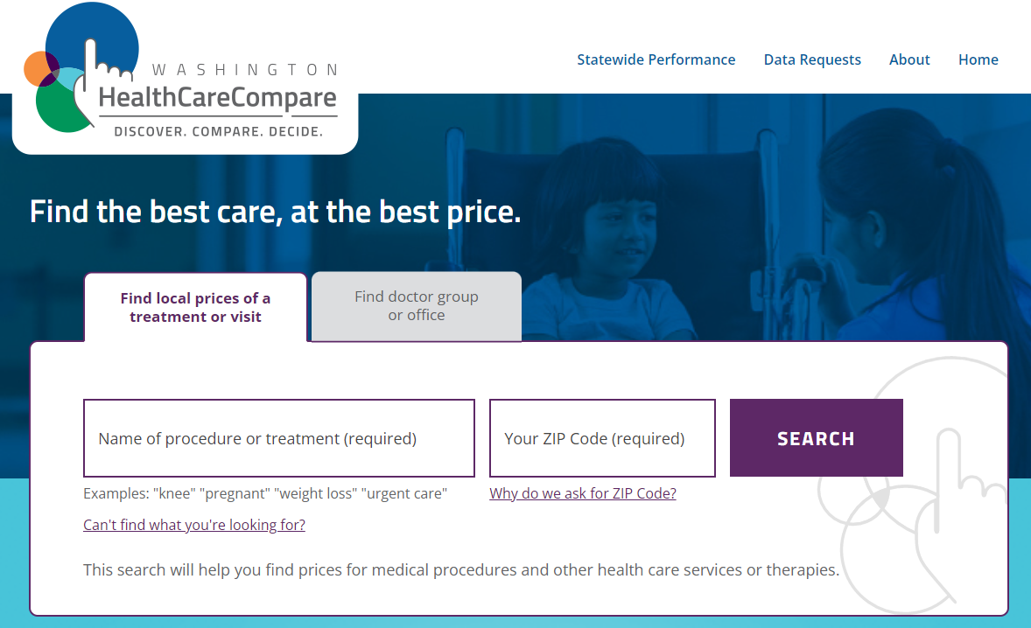
Figure 2 WAHCC homepage: find health care providers and facilities and compare the cost
and quality of medical care and services
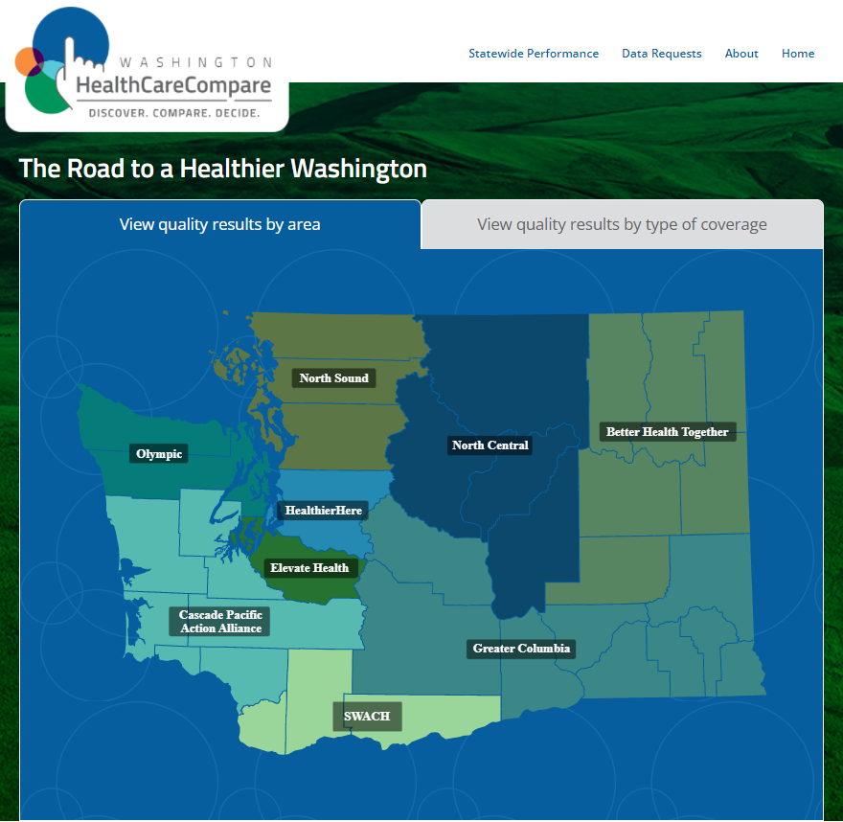
Figure 3 Compare the cost and quality across Accountable Communities for Health
The LO contracted with Forum One, the web vendor in compliance with the requirements of RCW 43.371.020(3) to ensure successful website operations during this reporting period.

Table 1 WA-APCD budget and expenditure detail
Total biennial WA-APCD program cost: $2,186,129
Fiscal Year | HCA Budget⁺ | Program Cost Item | Actual Expenditure
2020 | $1,053,000 | LO* | 237,936
 |  | Data Vendor | 411,190
 |  | Web Vendor | 21,505
 |  | CMS Medicare data | $8,100 (OFM expense)
 |  | NCQA# public reporting measure specifications data⁺ | $13,700
 |  | FY 2020 Total | $670,631
2021 | $2,222,000 | LO* | 130,662
 |  | Data Vendor$ | 1,266,170
 |  | Web Vendor | 118,666
 |  | CMS Medicare data& | $51,500
 |  | NCQA -public reporting measure specifications data& | $14,111
 |  | FY 2021 Total | $1,515,498
⁺HCA received partial year budget for FY20 as the agency oversight transfer effective date was 1/1/2020
&Medicare data costs in FY21 were for 2018 and 2019 data
*LO cost includes salary, benefits, goods and services (e.g., building costs, state agency data access), travel and equipment
#National Committee for Quality Assurance
$Includes new program cost of annual NCQA measure certification ($95,000)

As indicated in Table 1, HCA received partial year budget for FY 2020 as the agency oversight was effective January 1, 2020. The difference in cost of services between FY 2020 and FY 2021 is reflective of half the FY 2020 costs having been paid by OFM prior to January 1, 2020.
During this reporting period resources and attention were focused on program maintenance and transition planning with the expectation that HCA would transition LO functions to the Apparently Successful Bidder (ASB). Even with this focus on just program maintenance, utilization of WA-APCD resources, as indicated by website usage, increased by 55% over the reporting period.

Seeking funding

The Centers for Medicare & Medicaid Services matching funds
HCA received confirmation from the Centers for Medicare & Medicaid Services (CMS) that Medicaid funding at the 50% Federal Financial Participation (FFP) rate can be claimed for the Medicaid allocable share of WA-APCD operating costs. Federal regulations allow states up two years to make retroactive adjustments; HCA is in the process of making adjustments retroactive to January 2020. The Medicaid allocable share is 35%; based on the percentage of Medicaid covered lives (this equates to federal funding of 17.5% of total cost). The allocation to Medicaid funding will continue each year going forward.

WA-APCD performance

Submitter registration
During the reporting period, legislatively mandated data submitters registered each year to provide a range of basic information, including organization and contact details and estimated number of covered lives, average claims, and dollars paid. The WA-APCD program tracked this information, which served as a data quality and trending reference point for taking in submissions from each participating payer.

Data submission and monitoring
Data submissions were accepted through secure file transfer protocol (SFTP) with industry standard PGP (Pretty Good Privacy) encryption. The WA-APCD required data submitters to submit on a quarterly basis; submitted file types include eligibility, pharmacy, medical, and dental. Table 3 provides the types of claims and number of covered lives available in the database and the percentage of the WA population represented in the WA-APCD during calendar years 2019 and 2020. Data for 2021 is not yet available.

Table 3 WA-APCD covered lives and claims during calendar years 2019 and 2020, by market segment
WA-APCD Membership Counts - Medical and Pharmacy Eligibility
Market Segment | CY 2019 | CY 2020
Commercial | 2,076,611 | 2,081,398
Self-Insured | 409,098 | 505,660
Public Employees Benefits Board (PEBB) | 380,035 | 377,263
School Employees Benefits Board (SEBB) | - | 263,820
Exchange | 246,445 | 245,147
Medicaid | 2,021,340 | 2,011,673
Medicare Advantage | 413,284 | 490,617
Medicare FFS¹ | 898,733 | 888,912
Total Lives with Medical Coverage (including Medicare FFS estimate)² | 5,298,177 | 5,364,925
Total WA Population³ | 7,546,400 | 7,656,200
% of Total Population Captured (including Medicare FFS) | 70% | 70%
Other Insurance Markets
Dental | 4,399,468 | 4,732,586
Worker’s Compensation | 144,318 | 120,984
Out-of-State Lives | 2,194,717 | 3,044,680
¹ FFS estimated based on CMS statistics: https://www.cms.gov/Research-Statistics-Data-and-Systems/Statistics-Trends-and-Reports/CMSProgramStatistics/Dashboard.
² Total Lives with Medical Coverage include lives represented by Pharmacy claims and are less than the sum of the different plan types because some members may have had two types of coverage during the year. The totals reflect each member with any coverage during the year.”
³ Total WA population estimate based on OFM reporting: https://www.ofm.wa.gov/washington-data-research/statewide-data/washington-trends/population-changes/total-population-and-percent-change.

Submitters used credentials to access the Onpoint Claims Data Manager (CDM) secure reporting portal, which provided visibility on files’ submission progress, including up-to-date reporting on stage, status, reasons for file failure, and resubmission deadlines. Upon receipt, Onpoint decrypted data submissions and performed pre-load checks, and inspected for quality and compliance with fundamental submission requirements. This enabled tracking and reporting on compliance and resubmissions.
Data operations specialists followed each submisison from start to finish and provided submission support and updates throughout the process. Onpoint processed variance requests related to program completeness thresholds — most commonly when a data submitter’s system did not collect a required element or had special considerations based on the population that they serve. The LO monitored weekly submission status reports and provided submission communications to ensure compliance. The LO processed submitter applications for waivers, per WAC 82-75-080(2), and extensions, per WAC 82-75-080(3).

Data security and quality
The WA-APCD program adheres to industry-leading data privacy and security standards to protect the confidentiality of personal information and business data. Onpoint is in compliance with HIPAA security rules and has earned certified status by the Health Information Trust (HITRUST) Alliance. Onpoint provides technical assistance to data submitters’ technical staff to ensure they understand and meet the established data layouts, completeness thresholds, quality validations, and compliance processes.
The LO and Onpoint used methods and experts in health data assessment, while carefully following standard processes to check that the data is valid and reliable. These processes included:
- Data completeness and validity checks.
  - CDM data quality validation and threshold checks were performed to verify data quality and accuracy.
  - A battery of validations assessed the interrelationships of individual data elements and evaluated rates against parameter-driven thresholds to spot anomalies and errors.
  - Trending and cross-file quality checks examined data points, as their companion fields and data completeness changed over time.
  - Submitter attestation reports were delivered to each data supplier to validate their member counts, allowed amounts, and member payment responsibilities on a quarterly basis.
    - All WA-APCD data suppliers attested that the results provided to them were accurate.
- Cross-payer validation.
  - This validation step involved examination of post-consolidated, processed data to analyze specific metrics (e.g., demographics, rolling aggregation figures provider-and facility-related metrics, the quality of the master patient and provider indices).
- Quality, utilization, and expenditure metrics review.
  - Healthcare Effectiveness Data and Information Set (HEDIS) and other measures developed for the WA-APCD underwent extensive quality assurance and review by an independent measures-coding expert prior to rates being posted for provider review.
- Review and Reconsideration.
  - Providers and practices were afforded the opportunity to verify their quality, utilization, and expenditure measures annually, prior to public release through Onpoint’s Performance Reporting Portal.
- Program-initiated validation checks.
  - HCA and Onpoint conducted validation work to measure parity between data available through HCA’s ProviderOne operational data store (ODS) and WA-APCD, to improve the quality of HCA data submissions to the program. ProviderOne is the Washington state Medicaid Management Information System (MMIS) and is operated by HCA.
  - HCA, in its role as the LO, contracted with Mathematica to perform additional validation checks to further support the understanding of the quality of the WA-APCD Medicaid data. No significant findings were identified that raised concerns about the overall usability of the data.

The validation efforts undertaken over this reporting period, as well as data quality processes that have been implemented, have significantly improved the users’ confidence in the WA-APCD data accuracy. The 2020 legislative session also saw the passage of HB 2457 establishing the state’s Health Care Cost Transparency Board. The Board, staffed and supported by HCA, now utilizes the WA-APCD as a critical resource for meeting legislative requirements to report on health care expenditures and cost growth in Washington.

WA-APCD committees’ contributions to the database efficiency efforts†

State Agency Coordinating Committee
The State Agency Coordinating Committee, required in RCW 43.371.090(1), began meeting in 2020. It met quarterly in 2021 to ensure the database meets the needs of state agencies and other data users. This body consists of state agencies with related data needs and the Washington Health Benefit Exchange. The Coordinating Committee advised HCA and the LO on the development of database policies and data use agreements (i.e., 3M grouper use and NCQA measures) and rules relevant to agency data needs.

HCA WA-APCD Oversight Committee
The HCA WA-APCD Oversite Committee met monthly during fiscal years 2020 and 2021 to focus on strategic and cross-functional decision-making and program strategy development. Committee work encompassed the oversight and continuous improvement of the WA-APCD program processes and framework. The committee is responsible for ensuring adequate time is spent on strategic dialog, to ensure the database is meeting the needs of the state agencies and other data users. The committee also ensures procurement activities are conducted in line with applicable rules and regulations. Members include HCA executives and subject-matter experts.

WA-APCD Data Release Advisory Committee
The WA-APCD Data Release Advisory Committee, required in RCW 43.371.020(5)(h), met every other month during fiscal years 2020 and 2021 and provided input to the LO on formal data-release requests. Members include representatives of provider and consumer groups, health care purchasers, health plans, and state agencies involved in maintenance of the WA-APCD.

WA-APCD Data Policy Advisory Committee
The WA-APCD Data Policy Advisory Committee, required in RCW 43.371.020(5)(h), provided input on data collection, reporting, and related policies during fiscal years 2020 and 2021. Members include representatives of provider and consumer groups, health care purchasers, health plans, and state agencies involved in maintenance of the WA-APCD.

Select Committee
In response to ESSB 5741 (2019), which transitioned the management of the WA-APCD from OFM to HCA, HCA established a Select Committee of agencies, providers, plans, and other interested stakeholders. Its purpose was to convene key stakeholders and partners, to:
- Keep them informed of the transition plan that HCA and OFM completed jointly on July 1, 2019.
- Gather guidance, as HCA prepared to assume authority and oversight of the WA-APCD.
The major activities captured in the transition plan which enabled HCA to achieve the January 1, 2020, transition date included:
- Develop a transition and ongoing communication plan
- Transfer the data vendor contract
- Transfer the web vendor contract
- Transfer data use agreements
- Review and amend as appropriate the data submission process
- Review and amend as appropriate the data request process
- Develop and implement the process to annually refresh the cost and quality data on WAHCC
- Transition the existing governance oversight
- This group met regularly from June 2019, through December 2019, and provided insights and recommendations to assist during transition.
Additionally, HCA posted a Request for Proposal on August 13, 2019, for a Lead Organization. The solicitation documents were in alignment with the legislatively required procurement process, as well as the additional requirements outlined in ESSB 5741. HCA announced Washington Health Alliance as the apparent successful bidder on October 4, 2019. As of the date of this report, the parties have not reached agreement on a contract.
†See Appendix A: WA-APCD committee rosters

WA-APCD effectiveness

Increasing transparency using WA-APCD data

Washington HealthCareCompare (WAHCC)
Increasing access and transparency to health care cost and quality data for Washingtonians is essential to the original legislative vision of the WA-APCD. Making interactive tools available on WAHCC is one of the methods that HCA, acting in interim capacity as the LO, continued to employ during this reporting period to make the health care marketplace more transparent. The Common Measure Set is the foundation for WA-APCD quality reporting. The WA-APCD reportable Common Measure Set was incorporated into the website refresh two times during this period to promote awareness and transparency in the health care market by reporting on:
- Whether providers and health systems deliver efficient, high-quality care.
- Geographic and other variations in medical care and costs as demonstrated by data available to the LO.

WAHCC website utilization report
During this two-year reporting period, WAHCC site users interacted most with the provider cost and quality search pages, followed by the data request pages where users go to learn about applying for WA-APCD data. Geographically, the top three locations for users overall remained Seattle, Spokane, and Olympia. Comparing the two years, there was an increase in total users, from 6,718 to 10,429, which is a 55% increase. Additionally, over this two-year period there was a 115% increase in returning visitors, meaning that over twice as many users used the site multiple times during this period compared to the last. The number of search results more than doubled and organic searches remained the top channel for traffic origination, followed by referral from another website. This is important because one of the main goals of WAHCC has always been to grow organic traffic.

Data release program
During this FY2020/FY2021 reporting period, the LO managed the data release program. The LO provided data sets and customized reports to entities seeking to bring transparency to the cost of health care and inform development of innovative public health strategies aimed at supporting a healthier Washington. A broad array of customers used WA-APCD data, including:
- State agencies
- Public health departments
- Health care purchasers
- Researchers
- Hospital and medical associations
- Independent entities
Table 4 lists all the data release program clients, whose data use agreements were approved or whose data use agreements (DUAs) were amended/renewed during the reporting period. Release of WA-APCD data is allowable under Washington state statute (Chapter 43.371 RCW and Chapter 82-75 WAC). An application process, developed in accordance with WA statute, was implemented to ensure that the required steps in the data request and release process, including committee review, were executed. LO staff members worked with requestors throughout the data request process to provide technical assistance with items, such as:
- Identifying the best ways to tailor data requests to make best use of the WA-APCD data
- Understanding WA-APCD data privacy and security requirements
- Navigating the application process
The LO maintained a log on WAHCC of all requests and action taken on each request. The log includes information including the name of the requestor, data requested, and purpose of the request, and whether the request was approved or denied. This link can be used to reference the log: https://www.wahealthcarecompare.com/past-requests

Table 4 Data use agreement product types by organization
Organizations with approved Data Use Agreements | Product type
Washington State Department of Health† | Analytic Enclave
Washington Health Benefit Exchange† | Analytic Enclave
Public Health Seattle & King County† | Analytic Enclave
Providence health & Services - Oregon† | Analytic Enclave
Washington State Office of the Insurance Commissioner† | Analytic Enclave
OFM† | Analytic Enclave; Release Upon Request dataset
HCA† | Analytic Enclave
Washington State Hospital Association* | Analytic Enclave
Washington State Medical Association* | Analytic Enclave
Kaiser Foundation Health Plan of Washington* | Custom dataset
University of Rochester† | Release Upon Request dataset
VA Puget Sound Health Care System* | Custom dataset
University of Washington, Health Services Department* | Custom dataset
†State appropriations used to fund state agency access to data products during the two-year reporting period totaled approximately $380,000
*Data product gross revenue during the two-year reporting period totaled approximately $47,000.

Select WA-APCD use cases
A sample of use cases is provided below:

WA-APCD surprise billing data set
The Washington Balance Billing Protection Act, which become effective on January 1, 2020, aims to protect consumers from balance (or “surprise”) bills — specifically for:
- Out-of-network facility or provider charges billed to patients for emergency services, or Certain non-emergency services that patients receive at in-network hospitals or ambulatory surgical facilities.
In response to the Act, the state led a workgroup that included representatives from key stakeholder groups, including medical providers, hospitals, ambulatory surgical centers, and health insurance carriers.
The workgroup developed data set specifications, using commercial fee-for-service data from the WA-APCD, for a Surprise Billing Data Set. The Surprise Billing Data Set provides payment data for services subject to the Balance Billing Protection Act and was made available by The Office of the Insurance Commissioner in 2020 to assist insurers, facilities, providers, and arbitrators as an independent source of claims payment information.

Cost of diagnosed diabetes in Washington State
In December 2019, the Washington State Department of Health (DOH) published a Diabetes Data Supplement to the 2019 Diabetes Epidemic and Action Report to the Legislature. Using data from the WA-APCD, DOH provided insight into the financial impact of diabetes for individuals in the state. DOH estimated health care costs for WA-APCD members with diabetes totaled $4.9 billion in calendar year 2017 and provided additional health statistics. For example, the total average annual cost per member was much higher for people with diabetes ($23,761) compared to those without diabetes ($4,608).

Improving Parkinson’s disease care in underserved communities
VA Puget Sound Health Care System obtained a custom dataset to conduct a study to identify racial and geographic disparities in the care of Parkinson’s disease (PD) in Washington State, particularly King County. The study will use medical records (Medicare, Medicaid, and commercial) to characterize PD-related diagnoses, treatment, and specialty care in WA zip codes and to then determine how zip code or race/ethnicity may influence PD care. Using findings from these analyses, a pilot program will be designed to target underserved communities and help them better access specialist care and community services.

Other publicly published reports derived from WA-APCD data
Supported by legislatively appropriated funds, Washington state agencies also use data from WA-APCD and have published reports on their respective websites. As an example, OFM has produced various studies based on WA-APCD data (https://ofm.wa.gov/about/publications-and-reports). Recent examples include:
- COVID-19 diagnoses, treatments, outcomes, and costs in Washington All-Payer Claims Database, March-December 2020 https://ofm.wa.gov/sites/default/files/public/dataresearch/researchbriefs/brief103.pdf
- Increasing Diagnosis Severity in Hospital Discharges in Washington State, 2014-2019. https://ofm.wa.gov/sites/default/files/public/dataresearch/healthcare/pdf/increasing_diagnosis_severity_in_hsopital_discharges.pdf
- High-risk medications among older adults in Washington, 2014-2019. https://ofm.wa.gov/sites/default/files/public/dataresearch/researchbriefs/brief101.pdf
- Pharmacy Quality Alliance Opioid Prescribing Measures in Washington State, 2014-18. https://ofm.wa.gov/sites/default/files/public/dataresearch/researchbriefs/brief097.pdf
- Monitoring the Impacts of the Affordable Care Act in Washington. https://ofm.wa.gov/sites/default/files/public/dataresearch/healthcare/pdf/monitoring_the_impacts_of_the_ACA.pdf

WA-APCD data fee waivers and reductions
The LO provided WA-APCD funds in calendar year 2020 to a doctoral student with limited resources to pay for the cost of the requested data files (Release Upon Request data product). Requestors are required to meet specific criteria in order for the Data Release Advisory Committee members to consider granting fee waivers and reductions. Efforts such as these reflect HCAs firm commitment to supporting clinical and health policy research in line with the goals of current legislation.

Performance of the Lead Organization (LO)

LO Activity Summary
During this reporting period, HCA participated in all transition activities related to the transfer of the LO duties, responsibilities, and obligations from OFM to HCA to ensure that the WA-APCD Program remained fully operational through the transition. HCA, acting as LO, assumed all legal and contractual obligations of all contracts, including subcontracts and data use agreements in a manner that was seamless to the subcontractors, data release customers and data submitters.
Beginning, January 2020, HCA, acting as the LO, adhered to WA-APCD program requirements as specified in Chapter 43.371 RCW and Chapter 182-70 WAC and performed services required to coordinate, administer, manage, and operate the WA-APCD Program as the LO. This included:
- Overseeing the day-to-day operations, budgetary activities, and management of the WA-APCD Program.
- Ensuring collection of data from data suppliers as provided in RCW 43.371.030.
- Maintaining and improving data quality.
- Ensuring appropriate controls and protocols to protect the privacy and security of collected and released data.
- Developing a communications plan and ensuring delivery of required reporting and stakeholder communications.
- Making information from the database available as a public resource.

How the database can be improved
As outlined in Table 3, data in the WA-APCD represents 70% of covered lives in the state of Washington. While this provides a very large representation of healthcare usage in the state, there are opportunities for improvement that will enhance the public utility of WA-APCD as a trusted data sources for healthcare related clinical and policy research. Some of the ways in which the database can be improved is outlined below:
Extending and expanding datasets in WA-APCD
- Adding long term care data
- Encouraging voluntary submitters, e.g., local and county governments with self-insured plans
- Adding data subject to 42 CFR Part 2
- Adding vital statistics data from Washington State Department of Health
Enhancing value of database to public
- Increasing the number of publicly available datasets on WAHCC
- Improving healthcare cost transparency
Enhancing value of database to users
- Providing business intelligence and analytic tools in Analytic Enclave
- Coordinating data submission formats across states

Conclusion

Summary and next report contents
This report details the administration of the WA-APCD between July 1, 2019, and June 30, 2021 during which time the WA-APCD program transitioned from OFM to HCA, and HCA provided ongoing oversight of WA-APCD data submission, data release and consumer-facing website operations. HCA continues to engage with stakeholders onthe WA-APCD program’s contributions and further its ability to inform Washington State’s health care transformation efforts.

Appendix A:

WA-APCD committee rosters

WA-APCD State Agency Coordinating Committee:
- Vishal Chaudhry, Health Care Authority
- Kirsta Glenn, Department of Labor and Industries
- Leah Hole-Marshall, Washington State Health Benefit Exchange
- David Mancuso, Department of Social and Health Services
- Thea Mounts, Office of Financial Management
- Bryon Welch, Office of the Insurance Commissioner
- Ian Painter, Department of Health
- Amanda Pierpoint, Department of Corrections
WA-APCD Select Committee:
- Amanda Avalos, Health Care Authority
- Bill Ely, Kaiser Permanente
- Mary Fliss, Health Care Authority
- David Mancuso, Department of Social and Health Services
- Thea Mounts, Office of Financial Management
- Cathie Ott, Health Care Authority
- Charlie Parks, Premera Blue Cross
- Mandy Stahre, Office of Financial Management
- Ginny Weir, Bree Collaborative
WA-APCD Data Policy Advisory Committee:
- Suman Majumdar, Health Care Authority
- Amy Anderson, Association of Washington Business
- Jonathan Bennett, Washington State Hospital Association
- Jac Davies, Northwest Rural Health Network
- Charlie Parks, Premera Blue Cross
- Bill Ely, Kaiser Permanente
- Jeff Keim, Cambia Health Solutions
- Thea Mounts, Office of Financial Management
- John Vassal, Foundation for Healthcare Quality
WA-APCD Data Release Advisory Committee:
- Cathie Ott, Health Care Authority
- Jonathan Bennett, Washington State Hospital Association
- Matt King, Washington Technology Solutions (WaTech)
- Charlie Parks, Premera Blue Cross
- Mandy Stahre, Office of Financial Management
- Ginny Weir, Bree Collaborative
- Cyndy Harrison, Kaiser Foundation Health Plan of Washington (KPWA and KPNW)
HCA APCD Oversight Committee
- Vishal Chaudhry, HCA-CQCT
- Laura Shayder, HCA-DLS
- Mich’l Needham, HCA-POLICY
- Judy Zerzan-Thul, HCA-CQCT
- Annette Schuffenhauer, HCA-DLS
- Mary Fliss, HCA-CQCT
- Lorie Geryk, HCA-CQCT
- Lou McDermott, HCA Deputy Director

